Chapter 17, Solution 46.

(a)The MATLAB commands are:

t=0:0.01:5;
y=5*cos(3*t) – 2*cos(3*t-pi/3);
plot(t,y)

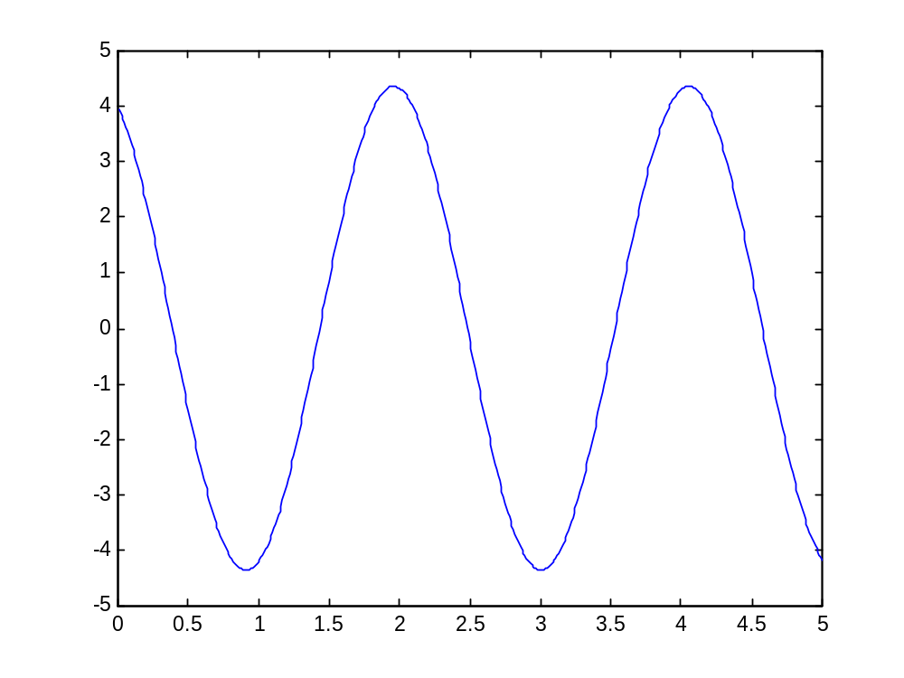

(b) The MATLAB commands are:

t=0:0.01:5;
» x=8*sin(pi*t+pi/4)+10*cos(pi*t-pi/8);
» plot(t,x)
» plot(t,x)
